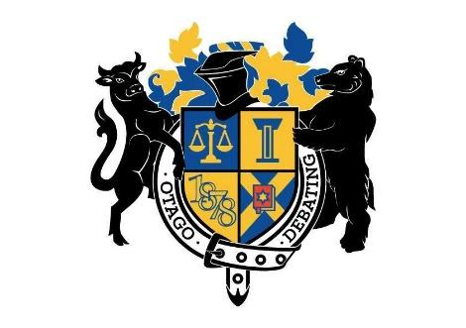

Otago University Debating Society Incorporated
Record of Executive Meeting

Date: 19/05/2022
Chair: Anna Roberts
Minutes Recorded by: Isaac Heron

In Attendance: Isaac Heron, Anna Roberts, Abby Bowmar, Ollie Meikle, Colby Allen, Georgia Barcley, Jaiden Tucker

Apologies: Amelia Mance

Record of Decisions made at the meeting:

Public

Matter: Clubs Day
Isaac has signed us up for the clubs day at the start of next semester.
- Vote: NA

Matter: Lazy Susan
This went very well, a lot of people came and it seems like people enjoyed it. We decided not to charge people who dropped out for food.
- Vote: Passed

Matter: Equity Survey
We checked the draft equity survey and made some changes before sending it out.
- Vote: NA

Matter: Officer’s Dates
AWDC is from 26-29 August, so if people want to go they would only have three days before Officer’s would start, so NZUDC is thinking of changing the dates to a month later on 23-25 September. We will ask to see if it can be moved to 17-18 September, because the suggested date is quite close to exams.
- Vote: Passed

Matter: SIIV Dates
Canterbury wants this to be on their break. We decided we would like to suggest SIIV to be over one of the Otago breaks as well, including potential mid-year break (we don’t know when their breaks are so will have to discuss this with them).
- Vote: NA

Matter: BYO & Bluff Final
We will do the BYO on the day of the Bluff final, on the final week (31st May). The BYO will be at Maharajas. Georgia will try and get Nicola Peart and Marcelo to come.
- Vote: NA

Matter: General Business
Anna has not received information about whether we have vice-chancellor funding for world’s or Sydney Mini.
- Vote: NA

